**ECEN 325 - Lab Report**

**Lab Number: 7**

**Lab Title: Characterization and DC Biasing of the BJT**

**Section Number: 503**

**Student’s Name:** [Alex Allahar](mailto:alex.allahar@tamu.edu)

**Student’s UIN: 928009686**

**Date: 10/29/23**

**TA: Mike Ng**

1. **Measurement Plots**
2. **NPN DC Sweep(V1) Ic vs Vbe Plot**

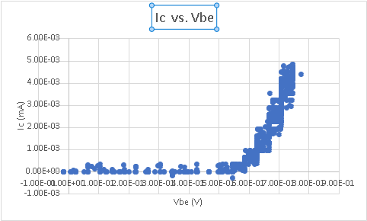

1. **NPN DC Sweep(V2) Ic vs Vce Plot**

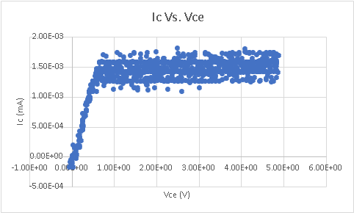

1. **PNP DC Sweep(V1) Ic vs. Veb Plot**

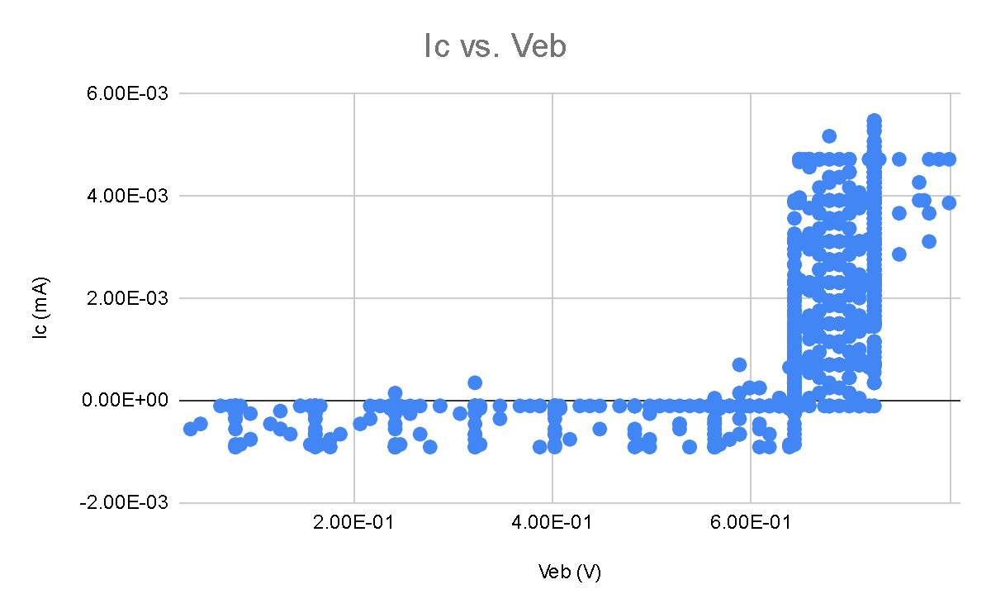

1. **PNP DC Sweep(V2) Ic vs. Vec Plot**

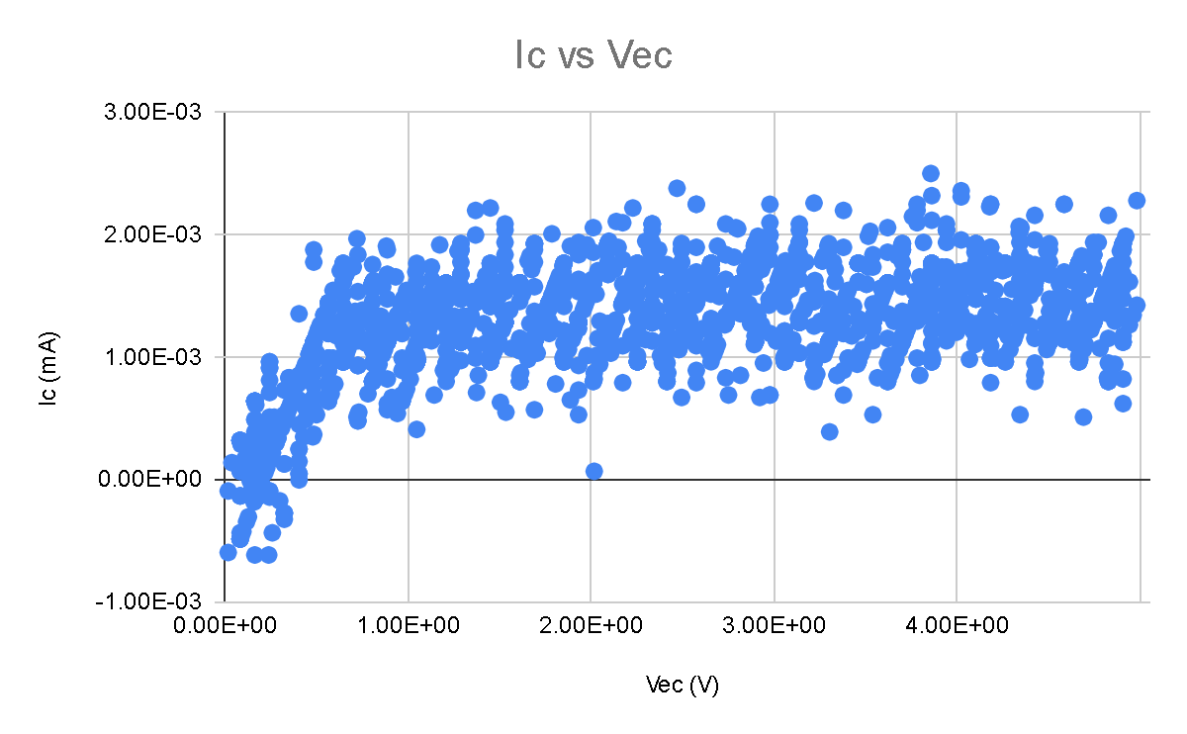

1. **NPN Resistive DC Biasing circuit**

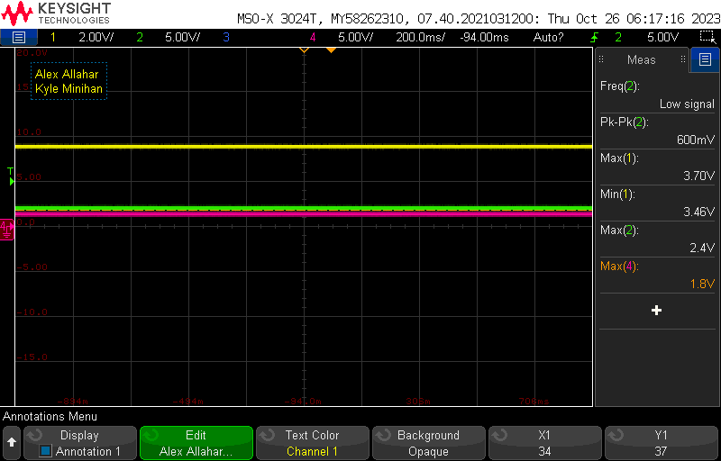

1. **PNP Resistive DC Biasing circuit**

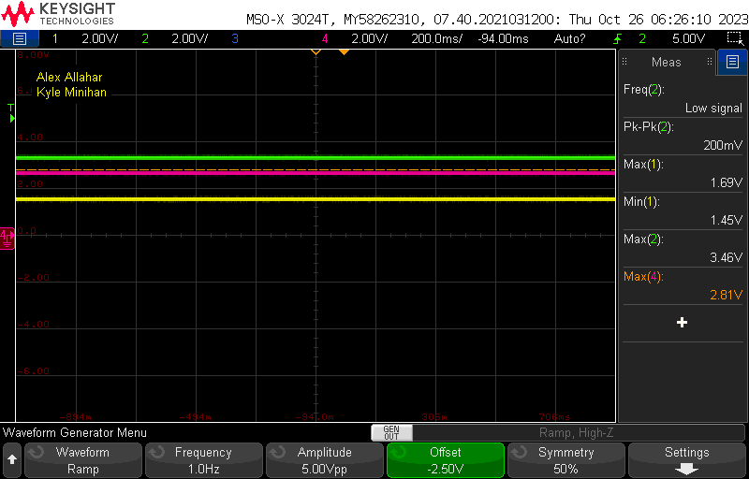

1. **NPN BJT using current source**

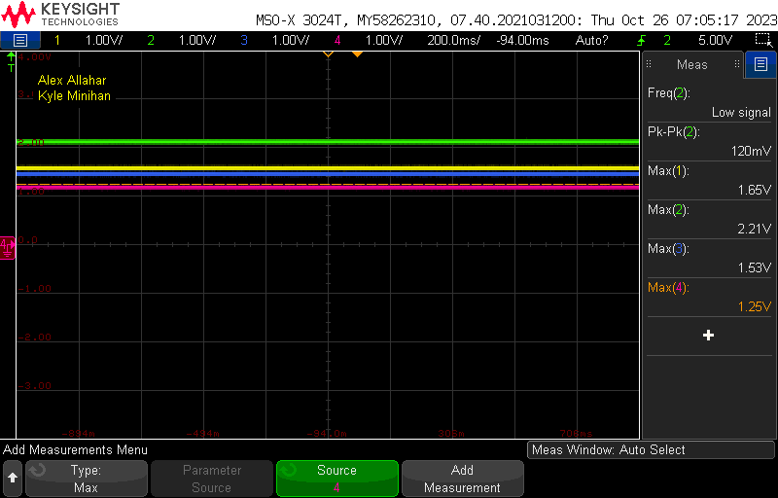

1. **PNP BJT using current source**

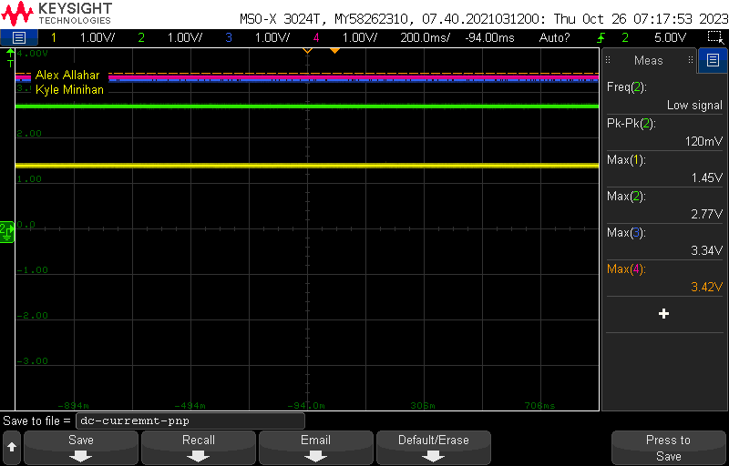

1. **Table**

| Value | Calculated | Simulated | Measured |
| --- | --- | --- | --- |
| Ic (#3) (NPN) | 1 mA | 1 mA | 1 mA |
| Vc (#3) (NPN) | 3.5 V | 3.5 V | 3.7 V |
| Vre (NPN) | > 1 V | > 1V | 2.4 V |
| V2 (NPN) | N/A | N/A | 1.8 V |
| Ic (#4) (NPN) | 2 mA | 2 mA | 2 mA |
| Vc (#4) (NPN) | 3.5 V | 3.5 V | 1.65 V |
| V2 (#4) (NPN) | N/A | N/A | 2.21 V |
| Vx (NPN) | > 1.5 V | > 1.5 V | 1.53 V |
| Vy (NPN) | N/A | N/A | 1.25 V |
| Ic (#3) (PNP) | 1 mA | 1 mA | 1 mA |
| Vc (#3) (PNP) | 1.5 V | 1.5 V | 1.7 V |
| Vre (PNP) | > 1 V | > 1 V | 1.54 V |
| V2 (PNP) | N/A | 1 mA | 2.81 V |
| Ic (#4) (PNP) | 2 mA | 2 mA | 2 mA |
| Vc (#4) (PNP) | 1.5 V | 1.5 V | 1.45 V |
| V2 (#4) (PNP) | N/A | N/A | 2.77 V |
| Vx (PNP) | > 1.5 V | > 1.5 V | 3.34 V |
| Vy (PNP) | N/A | N/A | 3.42 V |

1. **Compare the results and comment on the differences**

The NPN BJT using a current source did not work as intended. That is why the resulting values in the table above are not consistent with the table provided in the lab manual. We tested different transistors for the NPN current source and were unable to determine why it was unable to work with the previously made NPN Resistive circuit.